PIZZA SALES SQL QUERIES

# KPI REQUIREMENTS:

1. Total Revenue

Query: select sum(total_price) as total_revenue from Pizza_db.dbo.pizza_sales;

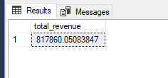

1. Average Order Value: average amount spent per order, total revenue by total no. of orders

Query: select sum(total_price) / COUNT(DISTINCT order_id) as avg_order_value from Pizza_db.dbo.pizza_sales;

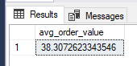

1. Total Pizzas Sold

Query: select SUM(quantity) as total_pizzas_sold from Pizza_db.dbo.pizza_sales;

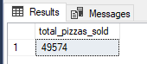

1. Total Orders

Query: select COUNT(order_id) as total_orders from Pizza_db.dbo.pizza_sales;

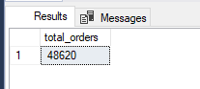

1. Average pizzas per order

Query : select CAST(CAST(SUM(quantity) as decimal(10,2)) / CAST(COUNT(DISTINCT order_id) as decimal(10,2)) as decimal(10,2)) as avg_pizzas_per_order from Pizza_db.dbo.pizza_sales;

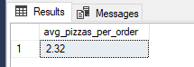

# CHART requirements:

1. Daily trend fot total sales

Q: select DATENAME(dw, order_date) as order_day, count(distinct order_id) as total_orders from Pizza_db.dbo.pizza_sales group by DATENAME(dw, order_date);

//DW (in datename function – dayofweek like Sunday, Monday..etc)

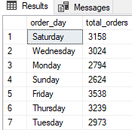

1. Monthly trends for total orders

select month(order_date) as month, count(distinct order_id) as total_orders

from Pizza_db.dbo.pizza_sales

group by month(order_date);

or

select DATENAME(MONTH, order_date) as month_name, count(distinct order_id) as total_orders

from Pizza_db.dbo.pizza_sales

group by DATENAME(MONTH, order_date) order by total_orders desc;

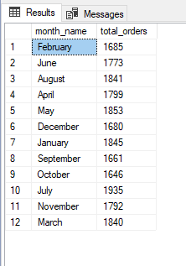 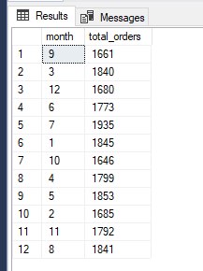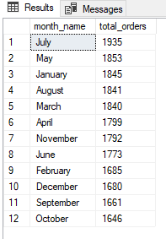

1. Percentile % of sales by pizza category

select pizza_category, sum(total_price) as total_sale, SUM(total_price)*100 / (select sum(total_price) from pizza_sales) as percent_sales from Pizza_db.dbo.pizza_sales group by pizza_category;

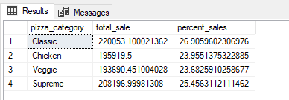

1. Percentile % of sales by pizza size

select pizza_size, round(sum(total_price),2) as total_sale,CAST(SUM(total_price)*100 / (select sum(total_price) from pizza_sales) as decimal(10,2)) as percent_sales from Pizza_db.dbo.pizza_sales group by pizza_size order by percent_sales desc;

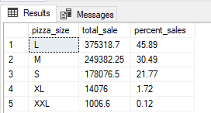

1. Total pizzas sold by pizza category

select pizza_size, round(sum(total_price),2) as total_sale,CAST(SUM(total_price)*100 / (select sum(total_price) from pizza_sales) as decimal(10,2)) as percent_sales from Pizza_db.dbo.pizza_sales

group by pizza_size order by percent_sales desc;

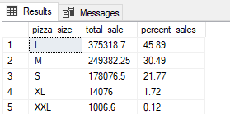

1. Top 5 Best sellers by revenue, total quantity and total orders

select top 5 pizza_name, SUM(total_price) as Revenue, SUM(quantity) as total_quantity, COUNT(distinct order_id) as total_orders from Pizza_db.dbo.pizza_sales group by pizza_name

order by Revenue desc;

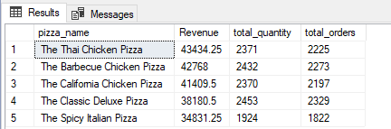

1. Top 5 least sellers by revenue, total quantity and total orders

select top 5 pizza_name, SUM(total_price) as Revenue,SUM(quantity) as total_quantity, COUNT(distinct order_id) as total_orders from Pizza_db.dbo.pizza_sales group by pizza_name order by Revenue;

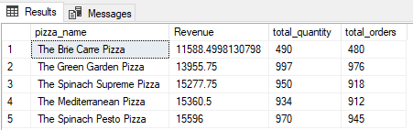

KPIs:

DAX functions

1. Total Revenue = SUM(pizza_sales[total_price])
2. Total Orders = DISTINCTCOUNT((pizza_sales[order_id]))
3. Avg Order Value = [Total Revenue]/[Total Orders]
4. Total Pizzas Sold = SUM(pizza_sales[quantity])
5. Avg Pizzas per Order = [Total Pizzas Sold] / [Total Orders]

Added day name column in power query using order date column

Again changed order day name (full day name) to first 3 chharacters using DAX function with ADD column option in ribbon of Table view.

Order Day = UPPER(LEFT(pizza_sales[Day Name], 3))

Order Month = UPPER(LEFT(pizza_sales[Month Name], 3))